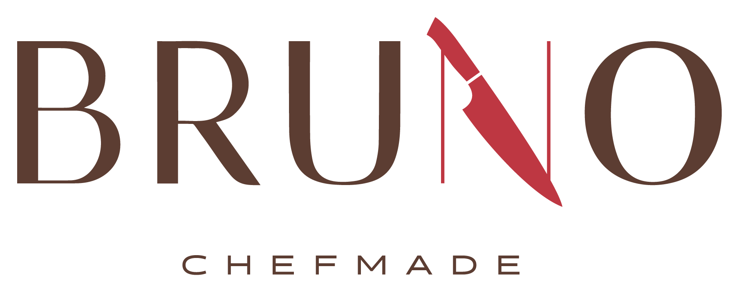

Breakfast
Monday - Thursday
a la carte only
8 am - 10 am

Lunch
Monday - Thursday
a la carte and daily specials
11 am - 1:30 pm

Brunch - Friday
Daily Special - Breakfast & Lunch + a la carte
10:00 am - 1:30 pm

MONDAY 8/10
Okie Day
SW BBQ Grilled Chicken
Fried Shrimp
Potato Wedges
Buttered Broccoli
Pickle Cream Cheese Bombs

TUESDAY 8/11
Mexican Day
Nacho Bar with
Mexican Ground Beef
Chicken Ranchero
Mexican Rice Mexican Corn
Savory Mexican Beans
Jalapeño Poppers

WEDNESDAY 8/12
BBQ Day
Smoked Ribs
Turkey Burnt Ends
Fried Okra Cole Slaw
Mashed Potatoes
Baked Beans Corn Fritters
Hushpuppies

FRIDAY 8/14
Brunch Day
Scrambled Eggs Bacon
Biscuits & Sausage Gravy
Pancakes Breakfast Potatoes
Fried Chicken
Chili Mac
Mashed Potatoes and Gravy
Veggie of the Day
THURSDAY 8/13
Mediterranean Day
Chicken Shawarma
Mediterranean Beef
Herbed Yellow Rice
Crispy Spicy Green Beans
Pita Bread


Custom & Express Catering Available for All Occasions
contact@BRUNOCHEFMADE.com 405.437.1660
www.BRUNOCHEFMADE.COM

Scan for
online ordering

