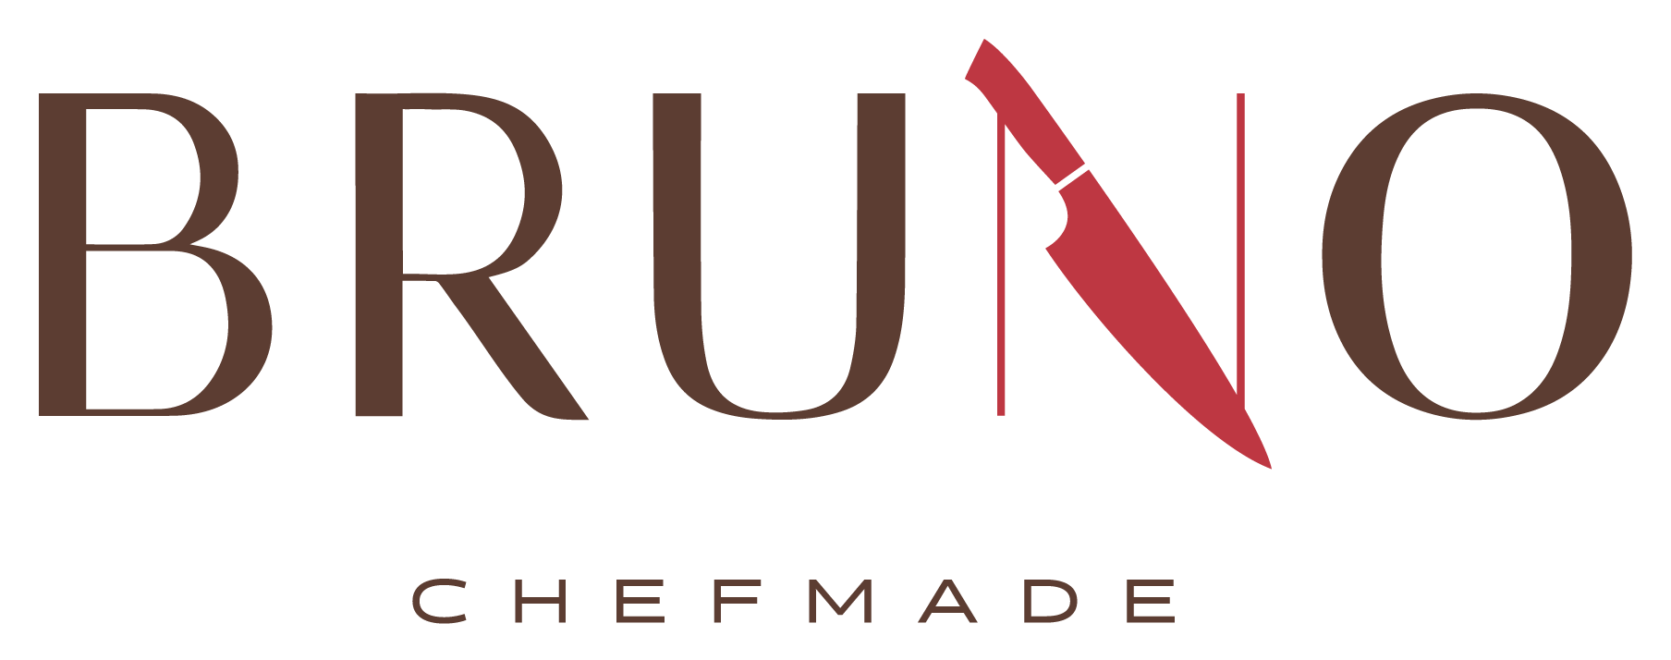

**Breakfast**

Monday - Thursday

a la carte only

8 am - 10 am

**Lunch**

Monday - Thursday

a la carte and daily specials

11 am - 1:30 pm

**Brunch - Friday**

Daily Special - Breakfast & Lunch + a la carte

10:00 am - 1:30 pm

TUESDAY 8/19

Mexican

Grilled Beef Fajitas

Ground Beef Tacos

Mexican Rice Frijoles

Adobo Roasted Zucchini

Mexican Roasted Corn

MONDAY 8/18

Okie Day

Burgers

Southwestern Grilled Chicken

Fries

Onion Rings

Sautéed Mixed Veggies

Mac & Cheese

WEDNESDAY 8/20

BBQ

Smoked Ribs Fried Catfish

BBQ Meatloaf

Mashed Potatoes and White Gravy

BBQ Baked Beans

Onion Rings Fried Okra

Buttered Peas and Carrots

Garlic Bread Sticks

THURSDAY 8/21

Italian

Chicken Parmesan

Sausage & Peppers Alfredo Pasta

Marinara Sauce

Rosemary Garlic Olive Oil Pasta

Buttered Green Beans

Garlic Bread Sticks

FRIDAY 8/22

Brunch

Scrambled Eggs Bacon

Biscuits & Gravy French Toast

Fried Chicken

Turkey Tetrazzini

Mashed Potatoes

Buttered Broccoli



Custom & Express Catering Available for All Occasions

contact@BRUNOCHEFMADE.com 405.437.1660

www.BRUNOCHEFMADE.COM

Scan for

online ordering